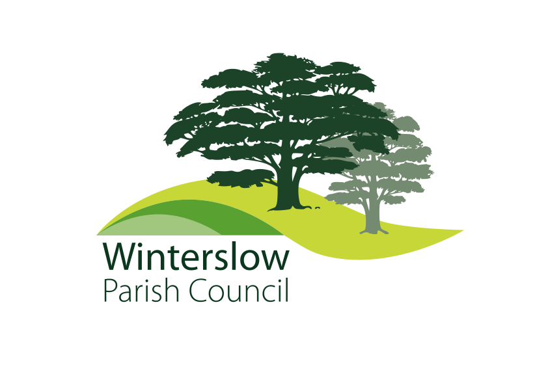

**DATE: 29th January 2025**

**To: All members of Winterslow Parish Council**

# **You are summoned to attend the February monthly Meeting of Winterslow Parish Council to be held at Winterslow Village Hall on Monday 3rd February 2025 at 7.30pm****.**

**For the purpose of transacting the following business;**

**Yours Sincerely**

**Jane Tier**

**Clerk to the Council**

*The Press and Public are invited to attend, and so there will be an Open Forum at the beginning of the meeting to allow members of the public to ask questions or make comments regarding the work of the Council or other items which affect the Parish. Please note that proceedings may be recorded.*

**AGENDA**

**001.25 To receive apologies.**

**002.25 Declarations of Interest:**

(a) To receive **Declarations of Interest** in respect of matters contained in this agenda

(b).To consider any **Dispensation Requests** received by the Parish Clerk and not previously considered.

**003.25 Minutes**

To consider and resolve to approve the minutes of the 13th January 2025 Monthly Parish Council meeting.

**004.25** To consider any **urgent business** raised by the public in public discussion, and any other urgent matters or items of information from councillors, or for referral to the appropriate working party.

**005.25 Planning applications.**

**PL/2025/00384**

**YEW TREE COTTAGE, LIVERY ROAD, WINTERSLOW**

**Consent under Tree Preservation Orders**

**006.25 Finance** – **To Resolve to agree:**

**a. The February monthly payments and agree the Bank.**

**b. To accept quote for repairs to windows at Barry’s Fields**

**c. The Clerk to purchase new car park signs at Barry’s Fields as proposed by the working group to a maximum value of £750**

**d. The Clerk to purchase 3 window blinds for Barry’s Fields as proposed by the working group to a maximum value of £300.**

**d. To accept quote for a Fire Risk assessment at Barry’s Fields**

**e. Terminology to be used when Cllrs discuss payments to external organisations**

**007.25 Highways / Footpaths**

*Parish Steward update from Cllr Moody*

*LHIG update from Cllrs Murton and Warnes*

*Wiltshire Council Footpath consultation. Update from Cllr Richardson.*

**008.26 Emergency planning, Village Hall ‘Hub’.**

*Update from Cllr Elder*

**009.25 Stones Close play area asset transfer**

*Update from Cllr Elder*

**010.25 Play equipment inspection**

**To agree to seek a contractor to carry out regular inspections.**

**011.25 Election 1st May 2025.**

*‘Purdah’ implications. Parish Clerk*

*Election process, key dates, and Parish Council Annual meeting dates / Annual Parish meeting dates. Parish Clerk*

**012.25 Parish Council communications and community engagement**

**General discussion on our approach to topics including:**

**May election and meeting dates**

**Emergency planning**

**New play equipment**

**New use/users for Barry’s Fields**

**013.25 Correspondence**

**014.25 To confirm the date of the next full council meeting, 3rd March 2025**

**015.25 To close the meeting.**